1. Operating environment： jdk 32 bit
2. Required software： idea、maven
3. Open the front-end interface：UHFReaderWeb\Index.html Modify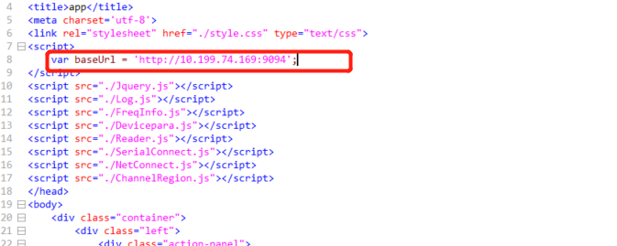

Change to http://local ip+9094

Import the project in idea, run the main function to start the project, and the jvm appears to indicate that the project runs successfully. Connect the hardware device. Double-click index.html. Select the port number and click the open button, then click the start button to start to read the card data.